Sysc 3010A Project Proposal

Group: W10

Archit Bhatia

David Casciano

Ross Matthew

Marko Simic

**About Us:**

We are group W10 for Sysc 3010A. Our group consists of third year Carleton Computer Systems Engineering students, Archit, David, Ross, and Marko. We are dedicated to creating a Smart Shelf which we want to bring to major stores across Canada.

**Context and Motivation:**

Our group has realized that store’s clerks have a hard time with keeping track of inventory along with knowing when a product is out of stock on shelves. Our Smart Shelf will overcome these problems by informing store clerks when an item has run out of stock on the shelf, by providing businesses with data of how much an item is left in stock, and this product will help society assisting small business owners get started by managing their shelves and inventory.

**Problem Statement:**

On a daily busy day store clerks have a hard time keeping track of which items have run out on the shelves. They tend to bring out skids with different items hoping the item hoping the items they brought out have room on the shelf. If the items they brought out are already on the shelf they waste time bringing it out and back to the back room again. Working in a retail store, the amount of customers who come complaining that the item they are looking for is not on the shelf. Then having us call the grocery clerks to check in the back for it to bring out. Our goal is to eliminate this complicated and time consuming process.

**Team Project Design:**

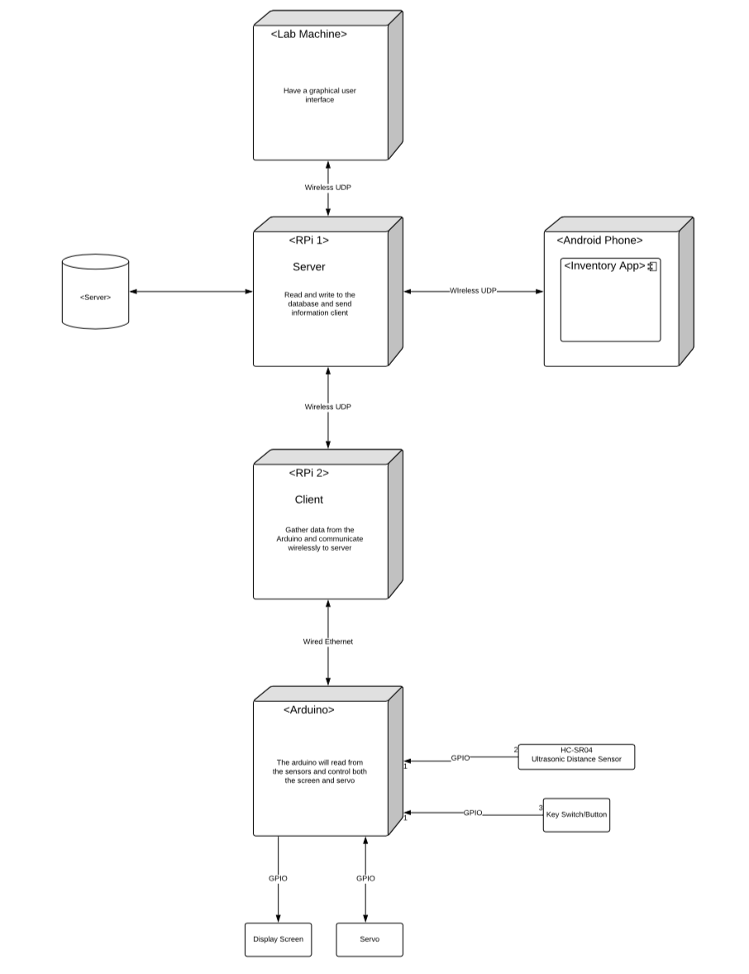

**Design Solution:**

The Smart Shelf will notify store management, employees and customers with a live inventory count of product availability. Having access to this information will increase the efficiency of employees ability to replenish products and eliminate unnecessary work. This information will be gathered by the Smart Shelf and then relayed to the employee via an android app which will show the state of the shelf’s inventory. The android app will also be able to be accessed by customers from their phone so that they will know in advance the current inventory of an item that they will be shopping for.

Function of Arduino:

The arduino will control a backing plate attached to a servo arm that will push the items on the shelf to the front as items are removed by customers. The backing plate will have a button in its centre which when compressed by the product will allow the arduino to know that there are no gaps in the shelf stock thus giving accurate inventory data to be collected. The arduino will know when it needs to extend the servo arm the fill the gap created by a missing product through the use of sensors. Two sensors will be placed at the front edge of the shelf and will detect when a product has been moved and inform the arduino. The sensors will also detect when the product being pushed by the backing plate has reached the front and no longer needs to be moved. An LCD display will also be placed at the front of the shelf to display the price of an item while there is stock on the shelf or it will display that an item is out of stock when the shelf is empty.

Data Collection Process:

The client side Pi which is on the Smart Shelf will gather data from the Arduino regarding the inventory of the shelf based on how far the servo arm has been extended. Based on the shelf length and the length which the arm has been extended the shelf inventory state will be determined. This information will be sent from the client side Pi to the server side Pi where the data will be used to update the shelf inventory.

Computer components:

We have two Pi’s included one for each shelf, an Arduino as described above, one of our Pi in standalone which will be the server, one Pi will be ssh in to run python script, one of the Pi will use both wired and wifi network connections, and the Android app will be used by the clerks to control the information.

Hardware components:

There are more than two sensors described above, there is one actuator connected to the arduino, there is a feedback loop that constantly checks the servers, and there is a 3D printed component which is the shelf base.

Software components:

There is a database which will store the information given off from the device, there is a periodic timing loop which will be collecting the data over a given amount of time, there is a GUI that will be used by the user to view the data obtained, and there is a bi-drectional UDP between the server side Pi and the multiple clients.

**Testing:**

All the features of the shelf will be tested together and individually. The parts that will be tested are the sensors, moving mechanism (servo motor), push buttons and inventory check (receiving and sending information).

Tests:

1) The push button will be tested to work correctly. The button will recognize that an item is being placed back on the shelf. Pressing each of the buttons must not affect the rest of the system. This should be reflected in the data as an item was placed back on the shelf.

2)The item sensor will be able to detect how many items are on the shelf and will be tested with accuracy. The sensors will be tested for accuracy to how many items are really on the shelf and how it is reflected in our data.

3) The Servo Motor will be tested thoroughly, for moving the items to the front of the shelf. This will be done by seeing what occurs when an item is removed. Next, it will be tested for when item is being placed back on the shelf, it must retreat and be able to be placed with ease. An item can be placed by a customer or an employee on the shelf. This will be tested to make sure the servo is moving items correctly

4) Data for the items and number of items will be collected and displayed on the GUI. First, the tests will include the appropriate data was received. Then, the system must ensure that data is displayed correctly.

5) The sensor will be tested for when the shelf is empty to show on the screen that the item is out of stock. This will signify to the employees that the shelf needs restocking. This will be tested by emptying the shelf and observing the outcome of the system.

The different sensors, buttons and servo motor will need testing in various cases to ensure each act accordingly. These situations will be monitored and reflected in data collection.

Once individual components are working, the system will be tested. together This will be done to see how each of the features work together as a group. This will ensure no other functionalities are affected when another feature is used.

**Engineering Process:**

